安裝gcc4.9教學

OS：Linux Ubuntu 18.04

1. 安裝
2. 修改優先權
3. 切換gcc

一、安裝

mkdir ~/Downloads/gcc-4.9-deb && cd ~/Downloads/gcc-4.9-deb

wget http://launchpadlibrarian.net/247707088/libmpfr4_3.1.4-1_amd64.deb

wget http://launchpadlibrarian.net/253728424/libasan1_4.9.3-13ubuntu2_amd64.deb

wget http://launchpadlibrarian.net/253728426/libgcc-4.9-dev_4.9.3-13ubuntu2_amd64.deb

wget http://launchpadlibrarian.net/253728314/gcc-4.9-base_4.9.3-13ubuntu2_amd64.deb

wget http://launchpadlibrarian.net/253728399/cpp-4.9_4.9.3-13ubuntu2_amd64.deb

wget http://launchpadlibrarian.net/253728404/gcc-4.9_4.9.3-13ubuntu2_amd64.deb

wget http://launchpadlibrarian.net/253728432/libstdc++-4.9-dev_4.9.3-13ubuntu2_amd64.deb

wget http://launchpadlibrarian.net/253728401/g++-4.9_4.9.3-13ubuntu2_amd64.deb

sudo dpkg -i gcc-4.9-base_4.9.3-13ubuntu2_amd64.deb

sudo dpkg -i libmpfr4_3.1.4-1_amd64.deb

sudo dpkg -i libasan1_4.9.3-13ubuntu2_amd64.deb

sudo dpkg -i libgcc-4.9-dev_4.9.3-13ubuntu2_amd64.deb

sudo dpkg -i cpp-4.9_4.9.3-13ubuntu2_amd64.deb

sudo dpkg -i gcc-4.9_4.9.3-13ubuntu2_amd64.deb

sudo dpkg -i libstdc++-4.9-dev_4.9.3-13ubuntu2_amd64.deb

sudo dpkg -i g++-4.9_4.9.3-13ubuntu2_amd64.deb

二、先改優先權

(1)使得安裝的gcc優先權是1000，g++因為從屬於gcc故不用動

sudo update-alternatives --install /usr/bin/gcc gcc /usr/bin/gcc-4.8 1000

sudo update-alternatives --install /usr/bin/gcc gcc /usr/bin/gcc-4.9 1000

三、切換gcc

(1)sudo update-alternatives --config gcc ##輸入要的版本 這裡是2

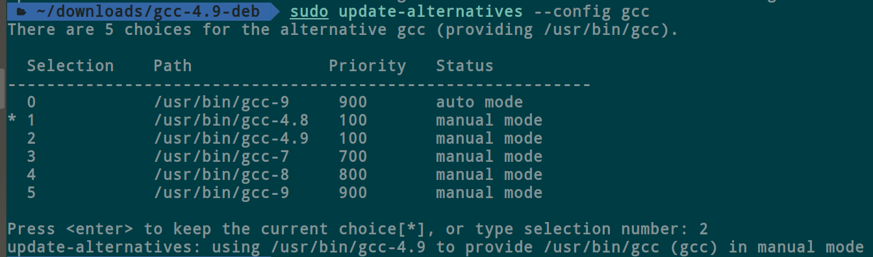

(2)gcc -v ##確認

